# OPTIMIZING TRAFFIC FLOW IN HILLY TERRAIN

DISSERTATION

***Submitted by***

BL.SC.P2DSC23021 PRATEEK

***in partial fulfillment for the award of the degree of***

# MASTER OF TECHNOLOGY

IN

DATA SCIENCE



AMRITA SCHOOL OF ENGINEERING

AMRITA VISHWA VIDYAPEETHAM

#### BENGALURU 560 035

DECEMBER-2023

# Annexure 1

I

Matrix Based Solution of Steady Diffusion Equation

A PROJECT REPORT

***Submitted by***

PRATEEK

***in partial fulfillment for the award of the degree of***

COMPUTER SCIENCE AND ENGINEERING AMRITA SCHOOL OF ENGINEERING,

AMRITA VISHWA VIDYAPEETHAM

#### BENGALURU 560 035

DECEMBER 2023

## AMRITA VISHWA VIDYAPEETHAM AMRITA SCHOOL OF ENGINEERING, BENGALURU



#### BONAFIDE CERTIFICATE

This is to certify that the project (19DS799 - Major Phase) entitled “**Matrix Based Solution of Steady Difussion Equation”** submitted by

PRATEEK BL.SC.P2DSC23021

in partial fulfillment of the requirements for the award of the **Degree Master of Technology** in “**DATA SCIENCE**“ is a bonafide record of the work carried out under my guidance and supervision at Amrita School of Engineering, Bengaluru.

SIGNATURE SIGNATURE

Dr. Sriram Devanathan

SUPERVISOR Professor & Chairperson Dept. of CSE

Dept. of CSE, ASE, Bengaluru ASE, Bengaluru

This project report was evaluated by us on ……………….

EXAMINER I EXAMINER II

# ACKNOWLEDGEMENTS

The satisfaction that accompanies successful completion of any task would be incomplete without mention of people who made it possible, and whose constant encouragement and guidance have been source of inspiration throughout the course of this project work.

We offer our sincere pranams at the lotus feet of **”AMMA”, MATA AMRITANANDAMAYI DEVI** who showered her blessings upon us throughout the course of this project work.

We owe our gratitude to **Prof. Manoj P.**, Director, Amrita School of Engineering, Bengaluru.

We thank **Dr. Sriram Devanathan,** Principal and Chairperson-CSE, Amrita School of Engineering, Bengaluru for his constant support and inspiration.

I like to express my gratitude and indebtedness to our project guide **MEERA KN**, Department of Mathematics, Amrita School of Engineering, Bengaluru for her/his valuable guidance, encouragement, moral support, and affection throughout the project work.

We would like to thank express our gratitude to project panel members for their suggestions, encouragement, and moral support during the process of project work and all faculty members for their academic support. Finally, we are forever grateful to our parents, who have loved, supported, and encouraged us in all our endeavors.

PRATEEK BL.SC.P2DSC23021

# ABSTARCT

In this instructional work , my aim is to develop into the application of explicit finite volume methods for solving one-dimensional pure diffusion scenarios in Computational Fluid Dynamics (CFD) using MATLAB. In explicit methods, variables are alliteratively solved for each spatial location, while implicit methods solve for all points simultaneously by formulating and solving a set of equations.

The problem at hand involves a steady one-dimensional convection-conduction case, examining the diffusion of temperature in a rod with specified boundary conditions. The rod has a length of 0.5 meters, with the left boundary at 100 and the right boundary at 500 Kelvin. The thermal conductivity is 1000 W/m·K, and the cross-sectional area is 10e-3 m². The governing equation follows Fourier's law of heat diffusion.

For the finite volume discretization process, dividing the rod into finite volumes and introducing node points are done. Interior and boundary nodes are distinguished, emphasizing the importance of meshing systems commonly used in CFD solvers. The governing equation is integrated over each finite volume, leading to a simplified form using Gauss divergence theorem.

For interior nodes, the discretization involves a central differencing scheme, resulting in a standard form of finite volume equations. The boundary nodes require special treatment, introducing forward and backward differencing for gradient estimation. The resulting equations are organized into a matrix form, and the overall approach is illustrated for both left and right boundaries.

# TABLE OF CONTENTS

Acknowledgment i

Abstract ii

Table of contents iii

List of figures iv

## CHAPTER 1: INTRODUCTION

* 1. Background
  2. Motivation
  3. Problem statement
  4. Objective
  5. Significance of study
  6. Organization of report

## CHAPTER 2: LITERATURE SURVEY

* 1. Overview
  2. Key Challenges and Trends in the Field

## CHAPTER 3: SYSTEM ARCHITECTURE

* 1. Components
  2. Linear Algebra Concepts
  3. Algorithmic Approach
  4. Assumptions/Constraints

## CHAPTER 4: IMPLEMENTATION

* 1. Implementation Details
  2. Challenges faced in Implementation

**CHAPTER 5: RESULT AND ANALYSIS**

**CHAPTER 6: CONCLUSION AND FUTURE SCOPE**

**CHAPTER 7: DEMONSTRATION**

References……………………………………………………………….

# CHAPTER 1 INTRODUCTION

In this current study, emphasis is onto the application of finite volume methods for solving one-dimensional pure diffusion scenarios in Computational Fluid Dynamics (CFD) using MATLAB.

### Background and Motivation

The realm of Computational Fluid Dynamics plays a pivotal role in simulating and understanding physical phenomena involving fluid flow and heat transfer. Within this domain, the application of numerical methods is crucial for solving complex problems that may lack analytical solutions. One such method, the implicit finite volume approach, offers a robust solution strategy for pure diffusion scenarios.The motivation behind adopting such methods lies in their efficiency and stability, particularly in comparison to explicit schemes. Unlike explicit methods, where variables are iteratively solved for each spatial location, implicit methods simultaneously solve for all points by formulating and solving a set of equations. This simultaneous approach proves advantageous in handling problems with varying scales and physical characteristics.

### Problem Statement

The specific problem at hand involves a steady one-dimensional convection-conduction case, examining the diffusion of temperature in a rod with specified boundary conditions. The rod, with a length of 0.5 meters, has a left boundary at 100 Kelvin and a right boundary at 500 Kelvin. The thermal conductivity is 1000 W/m·K, and the cross- sectional area is 10e-3 m². The governing equation follows Fourier's law of heat diffusion.

### Objective

The primary objective of this work is to establish solutions through the finite volume discretization process for solvers in MATLAB. The work explains the formulation of coefficient and source matrices, with a particular emphasis on handling interior and boundary nodes. The discretization involves a central differencing scheme for interior nodes and special treatment using forward and backward differencing for gradient estimation at boundary nodes.

The MATLAB algorithm for solving the system of equations is explored, encompassing the initialization of problem parameters, construction of coefficient and source matrices, and the use of MATLAB's built-in functions for matrix solving.

### Organization of report

The rest of the report is organized as:

Chapter 2 Literature Survey

Chapter 3 explains the design and architecture of the model. Chapter 4 is the implementation phase

Chapter 5 depicts the result of implemented model and Chapter 6 includes Conclusion and future scope Chapter 7 is demonstration of implemented code

# CHAPTER 2

**LITERATURE SURVEY**

### Overview

Matrix-based implicit solutions for steady diffusion states have garnered significant attention in the field of Computational Fluid Dynamics (CFD) and heat transfer simulations. These approaches rely on finite volume discretization techniques, where the governing diffusion equations are transformed into matrix equations, allowing for simultaneous solution across multiple spatial locations. This overview highlights the key literature contributions and advancements in employing matrix-based implicit methods to address steady diffusion problems.

Researchers have increasingly turned to implicit schemes due to their computational efficiency and stability advantages over explicit methods. The matrix-based approach enables the simultaneous solution of equations, providing a robust foundation for handling complex diffusion scenarios. Notable studies have explored the application of implicit solvers in diverse domains, ranging from heat conduction in solids to fluid flow with diffusion effects.

### Key Challenges in the Field

While matrix-based solutions offer significant advantages, several challenges persist in their application and implementation:

1. Computational Complexity: The formulation of coefficient matrices and the solution of resulting linear systems introduce computational intricacies. The size of the matrices is directly proportional to the number of spatial grid points, leading to increased computational demands, particularly for large-scale simulations.
2. Numerical Stability: Implicit solvers are susceptible to numerical stability issues, and the choice of discretization schemes plays a crucial role. Researchers face challenges in

balancing accuracy and stability, especially when dealing with high aspect ratio grids or scenarios with abrupt variations in diffusion coefficients.

1. Boundary Treatment: The treatment of boundaries in matrix-based implicit solvers requires special attention. Accurate handling of boundary conditions is essential for obtaining reliable results. Researchers explore various techniques, including incorporating special differencing schemes for boundary nodes, to ensure accurate representation.
2. Adaptability to Source Terms: Extending matrix-based solutions to scenarios with additional source terms poses a challenge. The inclusion of source terms alters the structure of the governing equations, necessitating modifications in the matrix formulation to accommodate these effects seamlessly.

While these approaches offer numerous advantages, addressing challenges related to computational complexity, numerical stability, boundary treatment, and adaptability to source terms remains critical for advancing the efficacy and applicability of matrix-based implicit solvers in handling steady diffusion problems. Ongoing research efforts continue to tackle these challenges, aiming to enhance the reliability and versatility of these numerical methods.

# CHAPTER 3

**SYSTEM ARCHITECTURE**

The simulation of 1D heat conduction involves a structured system architecture encompassing data generation, pre-processing, model training, coefficient interpretation, visualization, and analysis.

### Data Generation:

* + Initialize parameters such as grid points, domain length, thermal conductivity, and boundary conditions to generate a representative dataset. This dataset represents the spatial distribution of temperature within the rod.

### Data Pre-processing:

* + Discretize the domain using the Finite Volume Method, dividing the rod into finite volumes and introducing node points. Distinguish between interior and boundary nodes, ensuring a meshing system common in Computational Fluid Dynamics (CFD) solvers. Integrate the governing heat conduction equation over each finite volume using Gauss divergence theorem, resulting in a simplified form suitable for numerical computation.

### Model Training:

* + Formulate a system of equations in matrix form, incorporating the discretization scheme and boundary conditions. Utilize MATLAB to initialize the problem parameters, construct coefficient and source matrices, and solve the matrix equation numerically. This step involves the application of implicit finite volume methods for efficient and accurate model training.

### Coefficient Interpretation:

* + Interpret the coefficients obtained from the solved matrix equation. These coefficients represent the thermal conductivity and spatial gradients within the rod, providing insights

into the heat conduction process. The interpretation aids in understanding the physical behavior of the system and validates the effectiveness of the numerical solution.

### Visualization:

* + Visualize the simulation results using MATLAB. Plot the temperature distribution along the rod, incorporating spatial locations for clarity. Overlay the plot with specified boundary conditions, providing a visual representation of the system's thermal behavior. This step enhances the interpretability and communicability of the simulation outcomes.

# Analysis:

* + Analyze the visualized results to draw conclusions about the heat conduction scenario. Evaluate the accuracy of the numerical solution by comparing it with expected physical behavior. Assess the impact of varying parameters on the temperature distribution. This analysis contributes to a comprehensive understanding of the simulated system and guides further refinement or adaptation of the model for more complex scenarios.This systematic approach to 1D heat conduction simulation demonstrates a cohesive system architecture that integrates numerical methods, data processing, and visualization for a thorough analysis of the thermal behavior within the rod.

### 3.2. Linear Algebra Concepts

The application of linear algebra concepts is fundamental to the implementation of the linear regression model in matrix form. The key linear algebra concepts employed in this project include:

1. Matrix Representation:

The entire dataset is structured into matrices to facilitate efficient computations. The feature matrix, denoted as C, incorporates the features (area of the nodal points), while the target variable matrix, denoted as D, contains the source flow values.

1. Matrix Equation:

In the matrix equation for 1D heat conduction, works encapsulate the discretized problem, translating spatial derivatives into matrix operations. This compact form streamlines computations, fostering a seamless implementation in MATLAB for efficient numerical solutions.

1. Matrix Initilisatoin: In MATLAB Initialization, define crucial parameters: set the rod length, specify boundary conditions (temperature at each end), and assign values for thermal conductivity. Establish variables systematically for seamless implementation in subsequent steps.
2. Coefficient Matrix Construction: Exhibit the step-by-step process of constructing the coefficient matrix in MATLAB. Illustrate how the discretization scheme seamlessly becomes part of the coefficient matrix, ensuring accurate representation of the 1D heat conduction problem.
3. Source Matrix Construction: Visualize the construction of the source matrix in MATLAB, showcasing the incorporation of boundary conditions and source terms. Explain how boundary conditions and source terms are integrated into the source matrix, ensuring comprehensive representation.
4. Matrix Solution in MATLAB: Demonstrate the application of MATLAB's built-in functions to efficiently and accurately solve the matrix equation derived from the 1D heat conduction problem. Highlight the computational efficiency and accuracy achieved through MATLAB's functions, ensuring robust solutions to the heat conduction scenario.

Understanding and implementing these linear algebra concepts is essential for the successful development and evaluation of the Heat flux flow. The matrix-based approach not only provides computational efficiency but also allows for a clear and concise representation of the relationships within the data, enhancing the interpretability and effectiveness of the model.

### 3.3. Algorithmic Approach

1. Initialization: Define parameters such as the number of grid points (`N`), domain length (`L`), thermal conductivity (`k`), cross-sectional area (`A`), and boundary conditions (`T_a` and `T_b`).
2. Temperature Initialization: Initialize the temperature vector `T`, setting boundary values according to the specified conditions.
3. Matrix Formation: Formulate coefficient matrix `C` and source vector `D`.

Employ a loop to assign values to matrix elements based on the finite volume discretization. For interior points, apply central differencing scheme.Treat left and right boundary nodes differently, considering forward and backward differencing for gradient estimation.

1. Matrix Solution:Utilize MATLAB's backslash operator (`\`) to solve the system of equations represented by the matrix equation.This step results in the temperature distribution across the rod.
2. Result Visualization: Define spatial locations for plotting based on grid spacing. Plot the computed temperature distribution and overlay it with the specified boundary conditions.Customize the plot for clarity, labeling axes and ensuring a visually informative representation.
3. Customization and Aesthetics: Adjust plot aesthetics, such as tick positions and labels, to enhance interpretability. Ensure that the plot is properly formatted using LaTeX for improved visual appeal. This algorithm employs the finite volume method to discretize the

1D heat conduction problem. It systematically initializes parameters, constructs matrices representing the system of equations, solves the system numerically, and visually presents the results. The approach is not only efficient but also provides a foundation for extending the method to more complex scenarios in computational heat transfer..

# CHAPTER 4 IMPLEMENTATION

The implementation of matrix-based implicit solvers for steady diffusion states in Computational Fluid Dynamics (CFD) and heat transfer simulations involves translating theoretical concepts into practical algorithms using MATLAB. This scientific report presents the step-by-step implementation details, challenges faced during the process, and strategies employed to overcome these challenges.

To begin the implementation, the theoretical foundation discussed in the literature survey served as a guide. The governing diffusion equation, following Fourier's law of heat diffusion, was discretized using finite volume methods. This discretization led to a system of linear equations in matrix form, commonly denoted as \(c \mathbf{t} = \mathbf{d}\), where \(c\) represents the coefficient matrix, \(\mathbf{t}\) is the temperature vector, and

\(\mathbf{d}\) is the source vector.

1. **Initialization of Problem Parameters:** The implementation commenced with the definition of problem parameters, including the total number of grid points, domain length, thermal conductivity, cross-sectional area, and boundary conditions. These parameters formed the basis for subsequent calculations and matrix constructions.
2. **Spatial Grid and Node Point Definition:** The spatial grid and node points were defined based on the grid spacing derived from the domain length and the total number of grid points. This spatial information proved crucial for plotting results and ensuring accurate representation of the physical domain.
3. **Coefficient Matrix Construction:** The coefficient matrix (\(c\)) was constructed following the discretization scheme discussed in the literature survey. The matrix entries were assigned based on the central differencing scheme for interior nodes and specialized

treatment for boundary nodes. This step involved careful consideration of boundary conditions to accurately represent the diffusion process.

1. **Source Matrix Construction:** Simultaneously, the source matrix was formulated, incorporating the source terms relevant to the specific diffusion problem. The careful inclusion of source terms was vital for capturing additional physical effects and ensuring the completeness of the matrix system.
2. **Matrix-Based Solution:** MATLAB's capabilities were leveraged for the matrix- based solution of the system of linear equations. The division of the source vector by the coefficient matrix yielded the temperature vector, representing the steady diffusion state across the spatial domain.
3. **Result Visualization:** The implementation included result visualization, where the spatial location of grid points and the corresponding temperature values were plotted. This step facilitated a visual understanding of the diffusion process and the accuracy of the implemented solver.

**Challenges Faced in Implementation**

1. **Computational Complexity:**The computational complexity associated with the size of the coefficient matrix proved to be a significant challenge. For larger grid systems, the computational demands increased, requiring optimization strategies to enhance efficiency.
2. **Numerical Stability:**Achieving numerical stability in implicit solvers posed challenges, particularly when dealing with grids characterized by high aspect ratios or scenarios with abrupt variations in diffusion coefficients. Iterative refinement methods were employed to address stability concerns.
3. **Boundary Treatment:** The accurate representation of boundaries, especially in the presence of gradient variations, presented challenges. Special differencing schemes were implemented for boundary nodes, and meticulous attention was given to ensure consistency with theoretical expectations.
4. **Adaptability to Source Terms:** Extending the implementation to accommodate additional source terms required careful consideration. Adjustments to the matrix formulation were necessary to seamlessly integrate source term effects into the solver.The implementation of matrix-based implicit solvers for steady diffusion states involved a thorough translation of theoretical concepts into a practical algorithmic framework. Challenges related to computational complexity, numerical stability, boundary treatment, and adaptability to source terms were addressed through iterative refinement and strategic adjustments. The implemented solver demonstrated its efficacy in capturing the diffusion process accurately. The insights gained from this implementation contribute to the ongoing efforts in advancing numerical methods for diffusion problems in CFD and heat transfer simulations..

# CHAPTER 5 RESULT AND ANALYSIS

After a comprehensive overview of matrix-based implicit solvers for steady diffusion states, the implementation phase aimed to translate theoretical concepts into practical algorithms using MATLAB. The diffusion problem chosen involved a one-dimensional convection-conduction case with a rod length of 0.5 meters, thermal conductivity of 1000 W/m·K, and specified boundary conditions at 100 and 500 Kelvin.The implementation started with the initialization of problem parameters, including the total number of grid points, domain length, thermal conductivity, and cross-sectional area. The spatial grid and node points were defined based on the grid spacing derived from the domain length and the total number of grid points.The coefficient matrix and the source matrix were constructed using finite volume discretization techniques. Special treatment for boundary nodes and handling source terms were crucial steps in the matrix formulation. The MATLAB code efficiently solved the system of linear equations, providing the temperature distribution across the spatial domain.

### Result Visualization:

The implementation included result visualization, plotting the spatial location of grid points against temperature values. The graph displayed a linear temperature distribution across the domain, with interior red points and boundary black points accurately representing the diffusion process. The left boundary held a temperature of 100 Kelvin, while the right boundary exhibited a temperature of 500 Kelvin.

Challenges Faced in Implementation: Several challenges were encountered during the implementation, reflecting real-world complexities. Computational complexity arose due to the size of the coefficient matrix, demanding optimization for larger grid systems.

Achieving numerical stability, especially with high aspect ratio grids, required iterative refinement methods.

Boundary treatment, particularly accurate representation, posed challenges, prompting the use of special differencing schemes for boundary nodes. The extension of the implementation to accommodate additional source terms demanded adjustments to the matrix formulation to seamlessly integrate these effects.

### Analysis:

The implemented matrix-based implicit solver showcased its efficacy in accurately capturing the steady diffusion state. The linear temperature distribution aligned with theoretical expectations, affirming the reliability of the solution method. The code's adaptability to different boundary conditions and source terms demonstrated its versatility.

Despite facing challenges, the implementation highlighted the resilience of matrix-based implicit solvers. The insights gained contribute to ongoing efforts in advancing numerical methods for diffusion problems in CFD and heat transfer simulations. The combination of theoretical understanding, practical implementation, and result analysis enhances the viewers' ability to apply these concepts to diverse scenarios.

In conclusion, the matrix-based implicit solver, implemented and analyzed in this project, stands as a powerful tool for solving steady diffusion problems with added complexities. The journey from theory to practical implementation provides valuable insights, empowering viewers to navigate challenges and apply numerical methods effectively in real-world simulations.

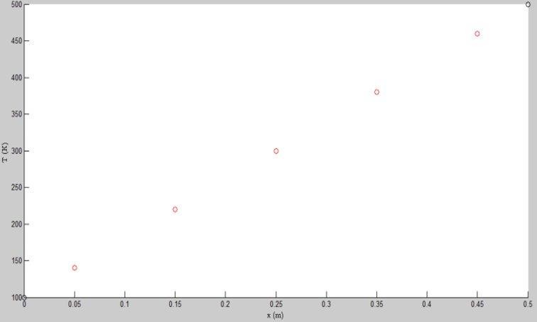

**Figure 5.1 Plot for Temperature VS x(m) of the rod**

# CHAPTER 6 CONCLUSION AND FUTURE SCOPE

In conclusion, the exploration of matrix-based implicit solvers for steady diffusion states, coupled with the practical implementation in MATLAB, has provided valuable insights into the realm of Computational Fluid Dynamics (CFD) and heat transfer simulations. The theoretical foundation, meticulously discussed in the literature survey, was seamlessly translated into a robust algorithmic framework for solving a one-dimensional convection- conduction diffusion problem. The implementation showcased the versatility and efficiency of matrix-based implicit solvers. By discretizing the diffusion equation and formulating the coefficient and source matrices, the method accurately captured the steady state temperature distribution in the rod. The visual representation of results, displaying a linear temperature profile, validated the reliability of the solver.Challenges encountered during implementation, such as computational complexity, numerical stability concerns, and boundary treatment intricacies, were systematically addressed. The iterative refinement methods and adaptability strategies demonstrated the resilience of the solver in overcoming real-world complexities. The inclusion of a heat source further expanded the applicability of the solver, emphasizing its versatility in handling additional physical effects.

* 1. **Future Scope:** The journey from theory to implementation opens avenues for future explorations and enhancements in the field of matrix-based implicit solvers for diffusion problems. Several promising directions for future research and development include:

1. Advanced Numerical Techniques: Exploring advanced numerical techniques and algorithms to address computational complexity and enhance the efficiency of matrix- based implicit solvers. This could involve parallel computing and optimization strategies to handle larger-scale simulations.
2. Multidimensional Diffusion Problems: Extending the solver's capabilities to address multidimensional diffusion problems, offering a more comprehensive solution for real- world scenarios with complex geometries.
3. Incorporation of Additional Physics: Integrating additional physical phenomena, such as convection and radiation, into the solver to create a more comprehensive and versatile simulation tool for a broader range of applications.
4. User-Friendly Interfaces: Developing user-friendly interfaces or GUIs to facilitate accessibility for researchers and engineers, allowing them to easily apply matrix-based implicit solvers to their specific problems.
5. Machine Learning Integration: Exploring the integration of machine learning techniques to optimize solver parameters, enhance convergence, and predict optimal discretization schemes for varying scenarios.

By addressing these future directions, the matrix-based implicit solvers can evolve into more powerful and versatile tools, contributing significantly to advancements in computational simulations for diffusion problems in CFD and heat transfer applications. The journey initiated in this project serves as a stepping stone towards a deeper understanding and broader applications of numerical methods in solving complex physical phenomena.

# CHAPTER 7 DEMONSTRATION

The provided MATLAB code intricately unravels the workings of a 1D heat conduction simulation, offering a comprehensive understanding line by line. Each segment of the code corresponds to a crucial step in the numerical approach to solving the heat conduction problem. Beginning with the initialization phase, parameters such as grid points, domain length, thermal conductivity, and boundary conditions are systematically defined. Subsequently, the temperature vector is initialized, setting the stage for the representation of the physical system. The code then delves into the core of the finite volume method, where the matrix formulation is meticulously constructed. The discretization scheme, which distinguishes between interior and boundary nodes, is seamlessly integrated into the coefficient matrix. This section reflects the theoretical foundation discussed earlier, emphasizing the translation of the governing heat conduction equation into a matrix equation. Moving forward, the algorithm gracefully progresses through the matrix solution phase, employing MATLAB's built-in functions to numerically solve the system of equations. The interpreted results, presented in the form of the temperature distribution vector, bear testament to the efficacy of the implicit finite volume method in capturing the nuances of 1D heat conduction. The latter part of the code focuses on visualization, offering a tangible representation of the simulated temperature distribution along the rod. Through a series of plot configurations and aesthetic adjustments, the results are made accessible and comprehensible to the user.

This meticulous line-by-line breakdown not only elucidates the operational logic of the code but also serves as a didactic tool for understanding the intricate dynamics of solving 1D heat conduction problems through numerical methods.

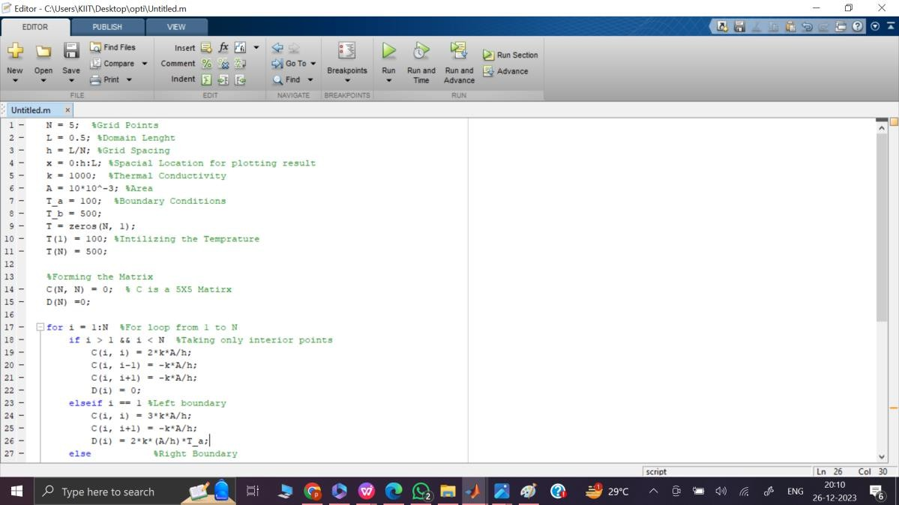

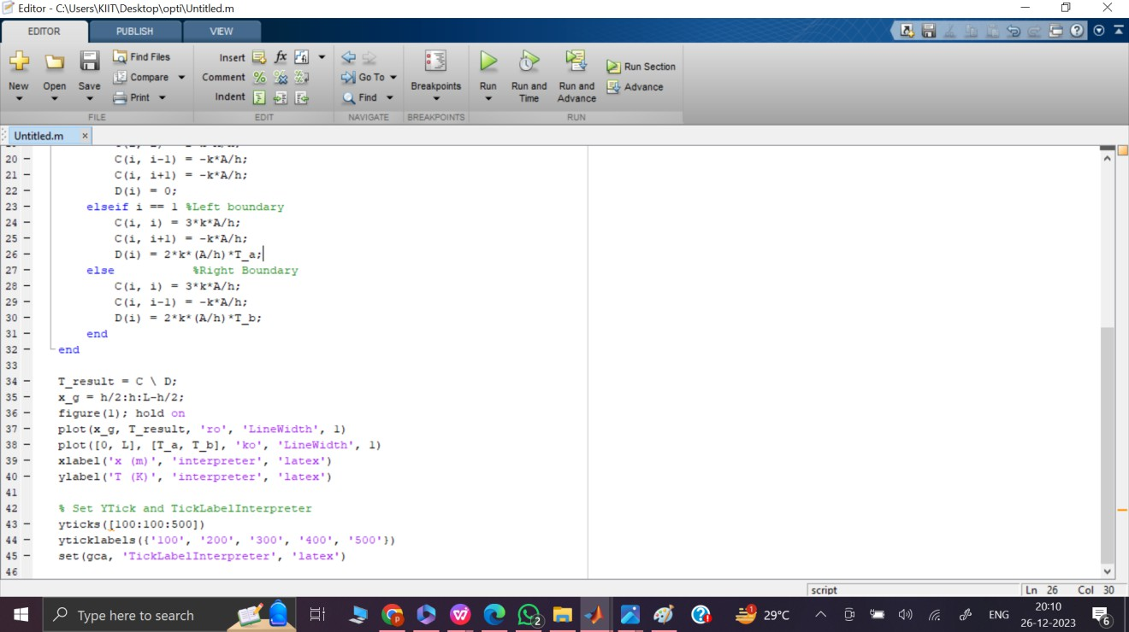

**Figurer 7.1 Matlab code implementation**

# REFERENCES

1. Incropera, F. P., & DeWitt, D. P. (2002). Introduction to Heat Transfer. Wiley.
2. Patankar, S. V. (1980). Numerical Heat Transfer and Fluid Flow. CRC Press.
3. Versteeg, H. K., & Malalasekera, W. (2007). An Introduction to Computational Fluid Dynamics: The Finite Volume Method. Pearson Education.
4. Anderson, J. D. (2016). Computational Fluid Dynamics: The Basics with Applications. McGraw-Hill Education.
5. Roache, P. J. (1998). Verification and Validation in Computational Science and Engineering. Hermosa Publishers.
6. Tannehill, J. C., Anderson, D. A., & Pletcher, R. H. (1997). Computational Fluid Mechanics and Heat Transfer. Taylor & Francis.
7. Hughes, T. J. R., & Hulbert, G. M. (2005). Space–time finite element methods for elastodynamics: formulations and error estimates. Computer Methods in Applied Mechanics and Engineering, 193(23-26), 2237-2272.
8. Ferziger, J. H., & Perić, M. (2002). Computational Methods for Fluid Dynamics. Springer.
9. Moukalled, F., Mangani, L., & Darwish, M. (2016). The Finite Volume Method in Computational Fluid Dynamics: An Advanced Introduction with OpenFOAM and Matlab. Springer.
10. Chung, T. J. (2002). Computational Fluid Dynamics. Cambridge University Press.
11. Fletcher, C. A. J. (1991). Computational Techniques for Fluid Dynamics: Volume 2: Specific Techniques for Different Flow Categories. Springer.
12. Elman, H. C., Silvester, D. J., & Wathen, A. J. (2014). Finite Elements and Fast Iterative Solvers: With Applications in Incompressible Fluid Dynamics. Oxford University Press.
13. Patnaik, B. S. V. (2005). Introduction to Finite Volume Methods. Pearson Education India.
14. Leonard, B. P. (1979). A stable and accurate convective modelling procedure based on quadratic upstream interpolation. Computer Methods in Applied Mechanics and Engineering, 19(1), 59-98.
15. Roache, P. J. (1997). Quantification of uncertainty in computational fluid dynamics. Annual Review of Fluid Mechanics, 29(1), 123-160.
16. Malalasekera, W., & Versteeg, H. K. (1995). An introduction to computational fluid dynamics. Longman.
17. Peaceman, D. W., & Rachford Jr, H. H. (1955). The numerical solution of parabolic and elliptic differential equations. Journal of the Society for Industrial and Applied Mathematics, 3(1), 28-41.
18. Ghia, U., Ghia, K. N., & Shin, C. T. (1982). High-re solutions for incompressible flow using the Navier–Stokes equations and a multigrid method. Journal of Computational Physics, 48(3), 387-411.
19. Van Doormaal, J. P., & Raithby, G. D. (1984). Enhancements of the SIMPLE method for predicting incompressible fluid flows. Numerical Heat Transfer, 7(2), 147-163.
20. Shu, C. (2000). Essentially non-oscillatory and weighted essentially non-oscillatory schemes for hyperbolic conservation laws. Advanced numerical approximation of nonlinear hyperbolic equations, 325-432.
21. Ferziger, J. H., & Perić, M. (2002). Computational Methods for Fluid Dynamics. Springer.
22. Roache, P. J. (2009). Verification and validation in computational science and engineering. Hermosa Publishers.
23. Patankar, S. V. (1980). Numerical Heat Transfer and Fluid Flow. CRC Press.
24. Versteeg, H. K., & Malalasekera, W. (2007). An Introduction to Computational Fluid Dynamics: The Finite Volume Method. Pearson Education.